security group is stateful

network acl is stateless

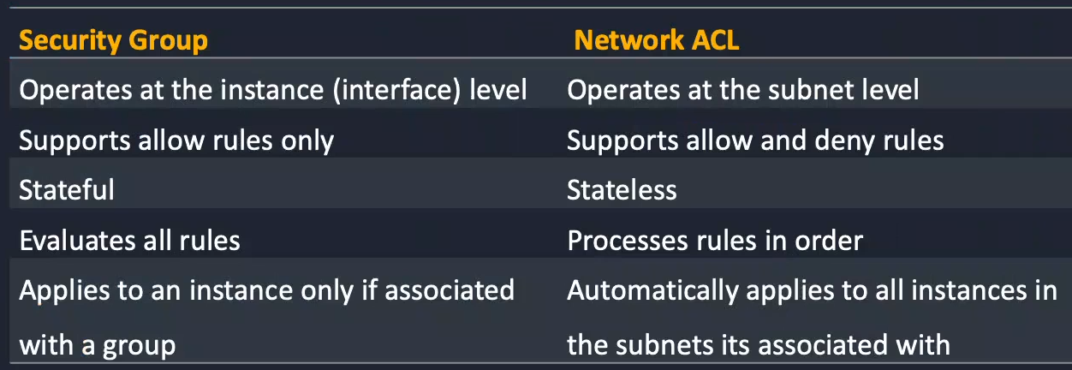

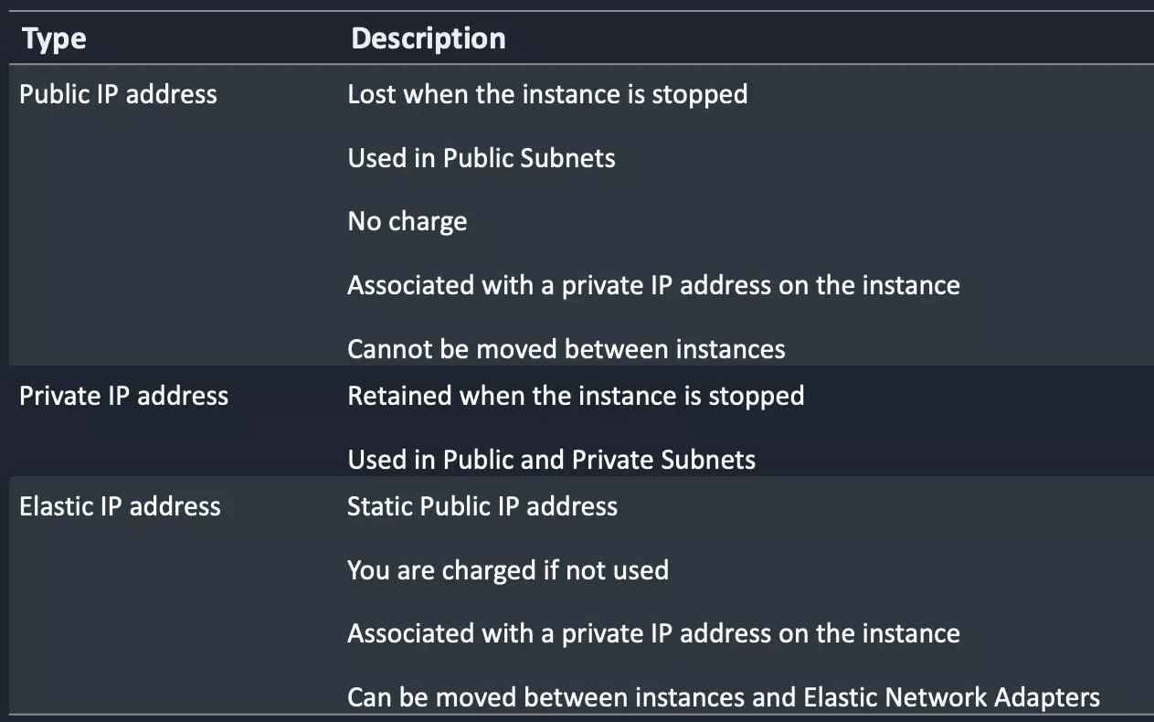

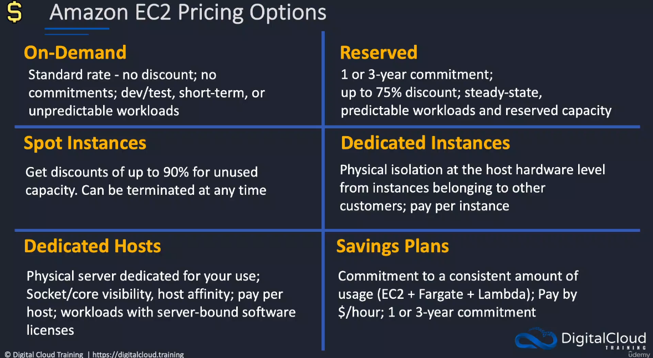

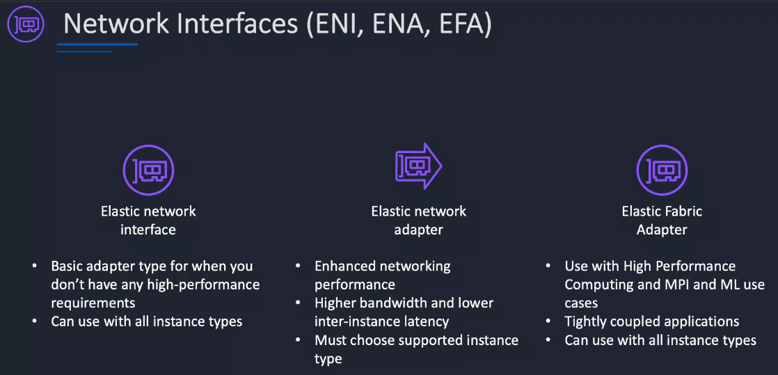

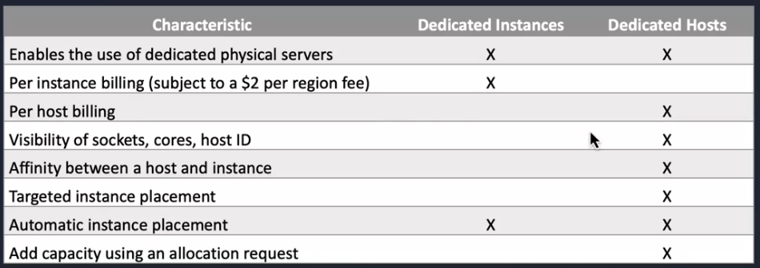

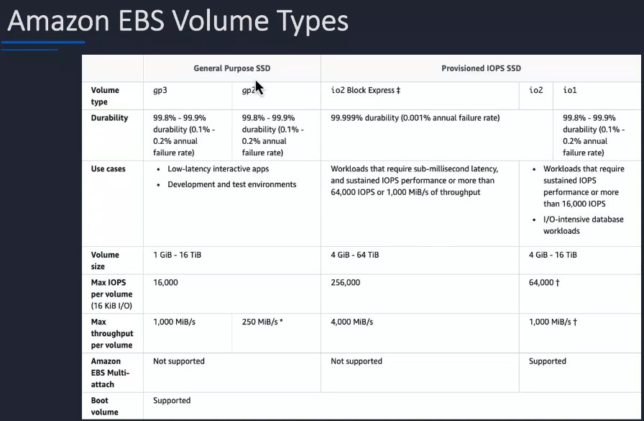

What is a virtual private gateway (VGW)?

A virtual private gateway (VGW) is part of a VPC that provides edge routing for AWS managed VPN connections and AWS Direct Connect connections. You associate an AWS Direct Connect gateway with the virtual private gateway for the VPC.

IGW – internet gateway

An Elastic IP address is a reserved public IP address that you can assign to any EC2 instance in a particular region, until you choose to release it.

ELB - A lifecycle hook provides a specified amount of time (one hour by default) to wait for the action to complete before the instance transitions to the next state.

EC2 auto scaling - What is scheduled scaling policy?

Scheduled scaling helps you to set up your own scaling schedule according to predictable load changes. For example, let's say that every week the traffic to your web application starts to increase on Wednesday, remains high on Thursday, and starts to decrease on Friday.